**Installing of Jupyter:**

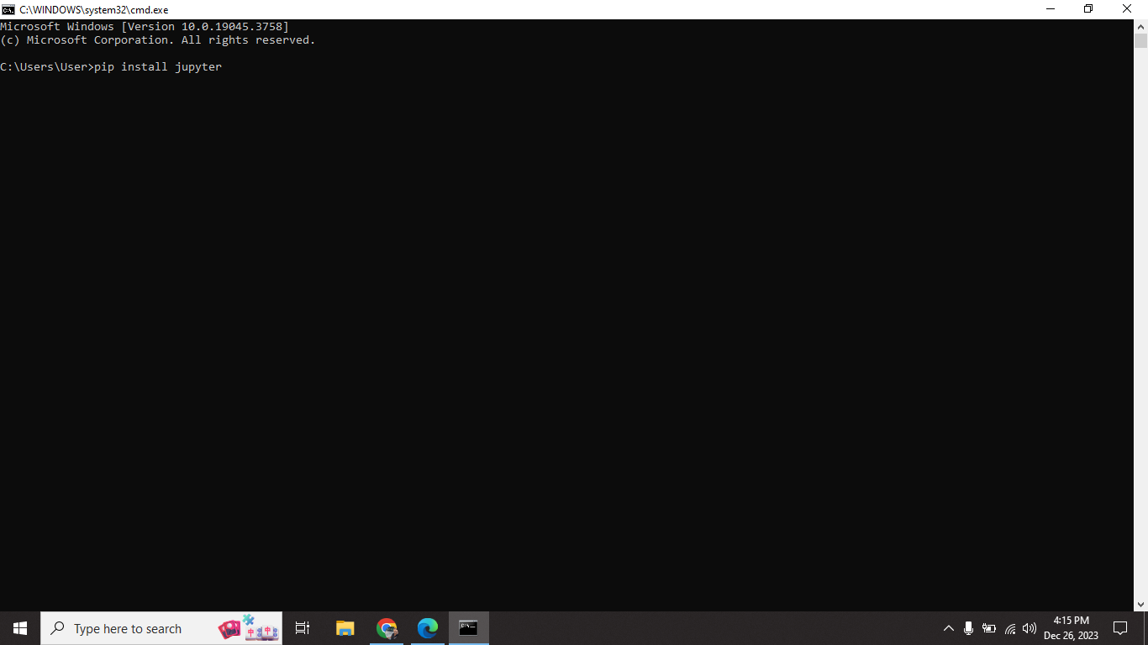

**Installing of findspark module:**

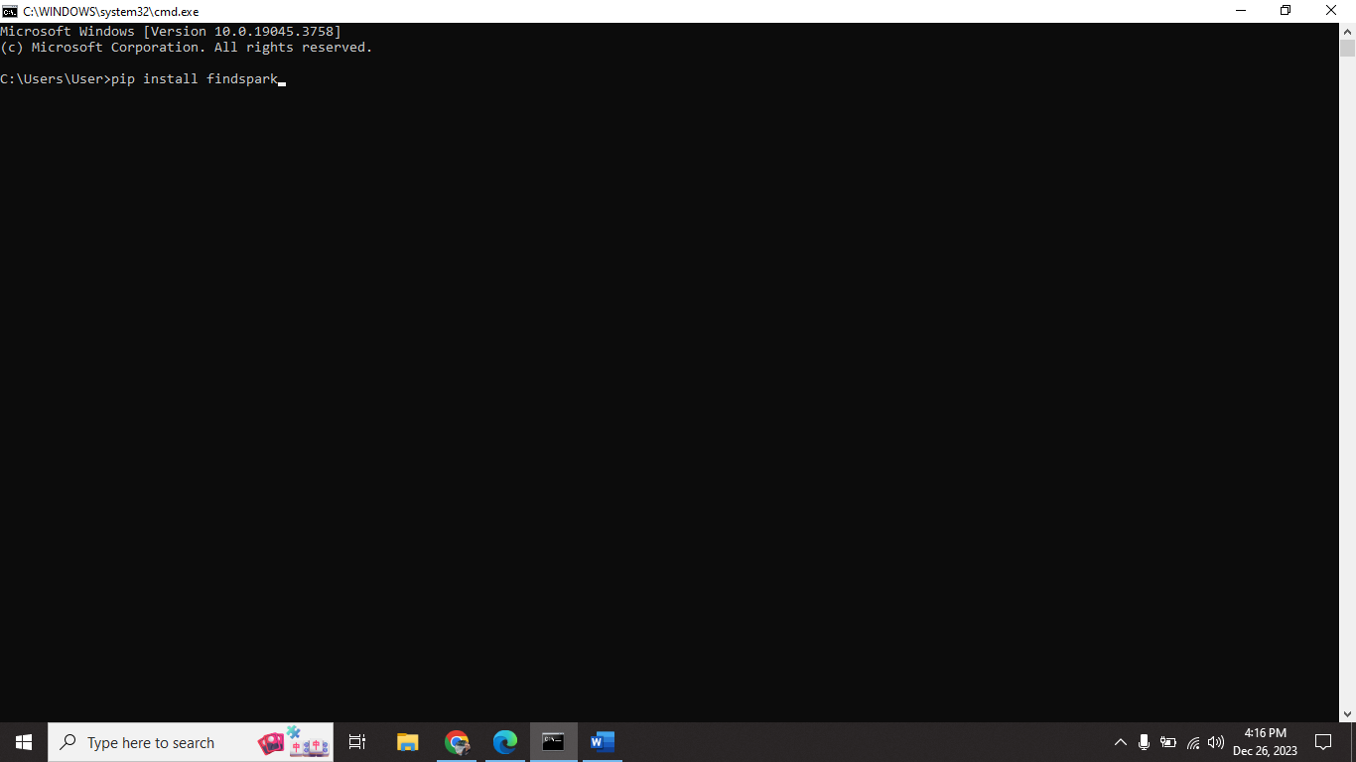

**Opening localhost jupyter webpage:**

**Enter command on cmd:**

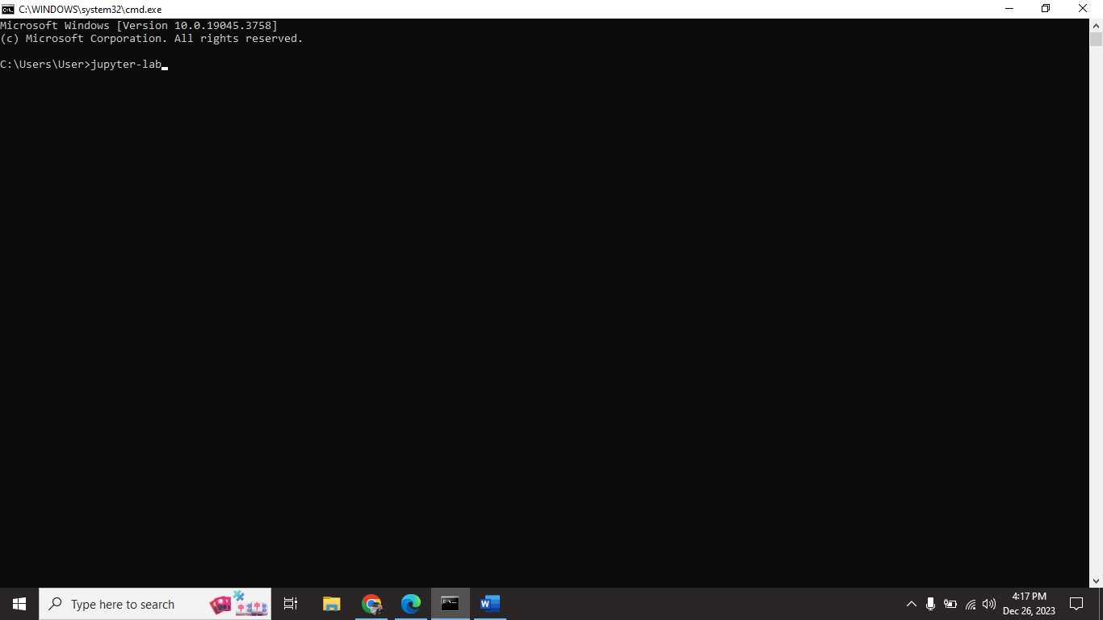

**Launching jupyter from cmd:**

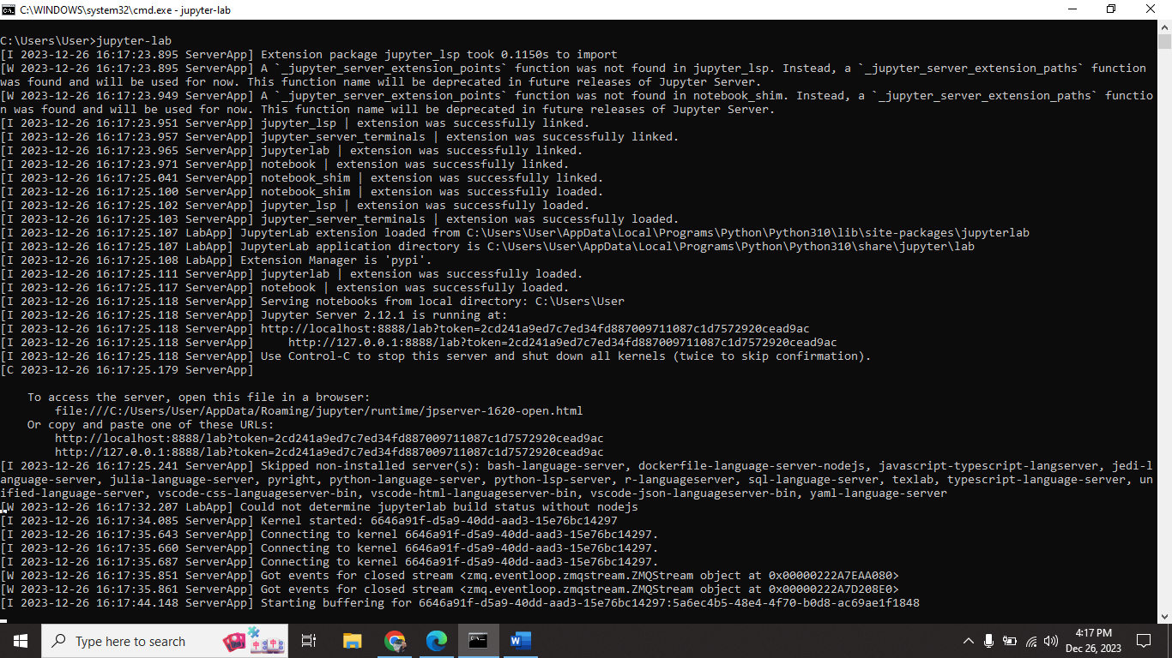

**Redirect to localhost:8888 page:**

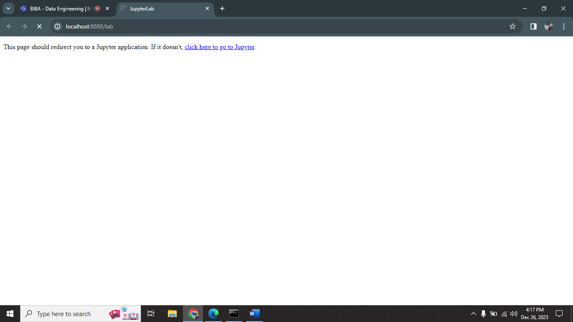

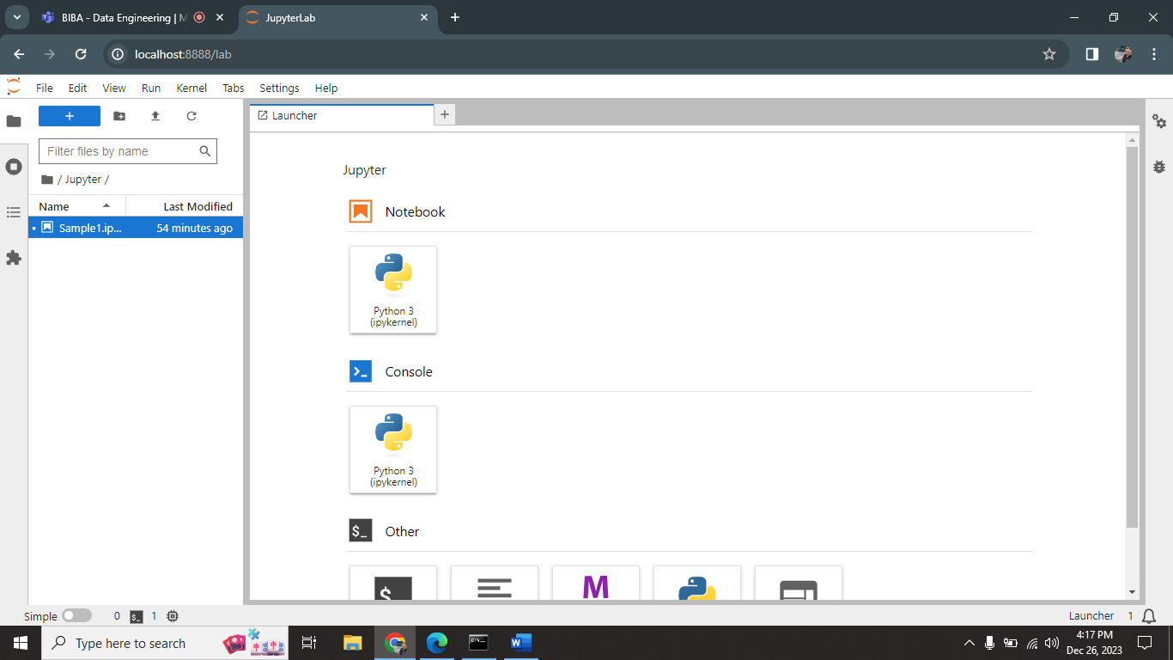

**Executing Sample code on localhost page:**

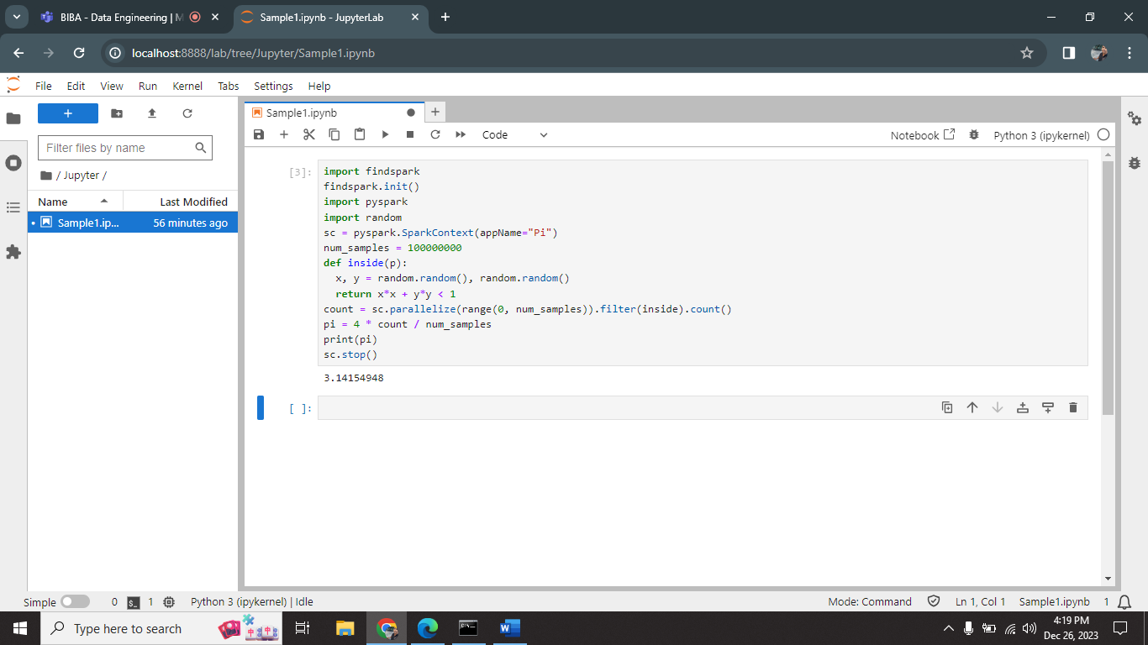

I successfully run one basic code on jupyterlab.

**Using Jupyter on VS Code:**

**Download Jupyter extension:**

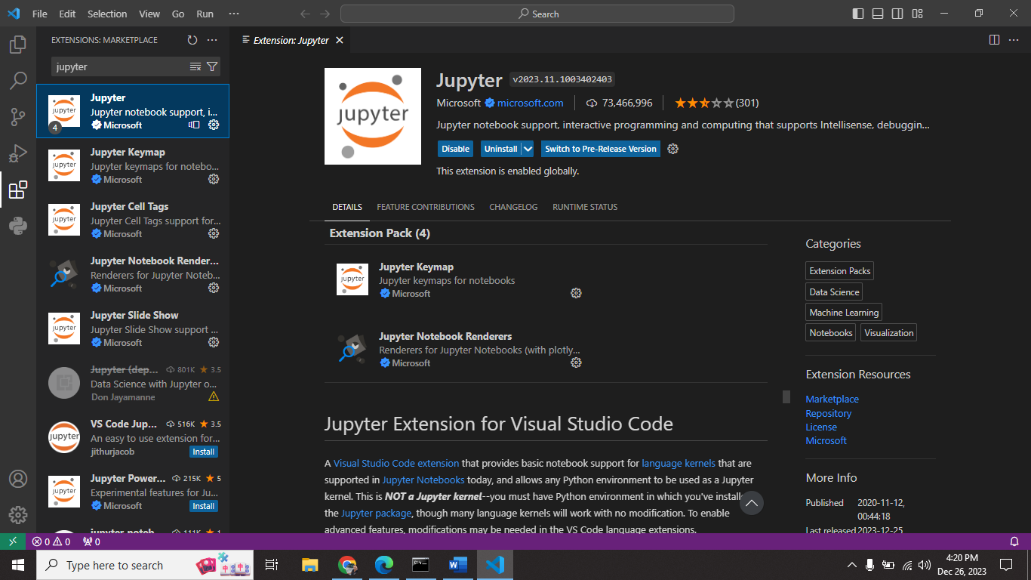

**Code execution:**

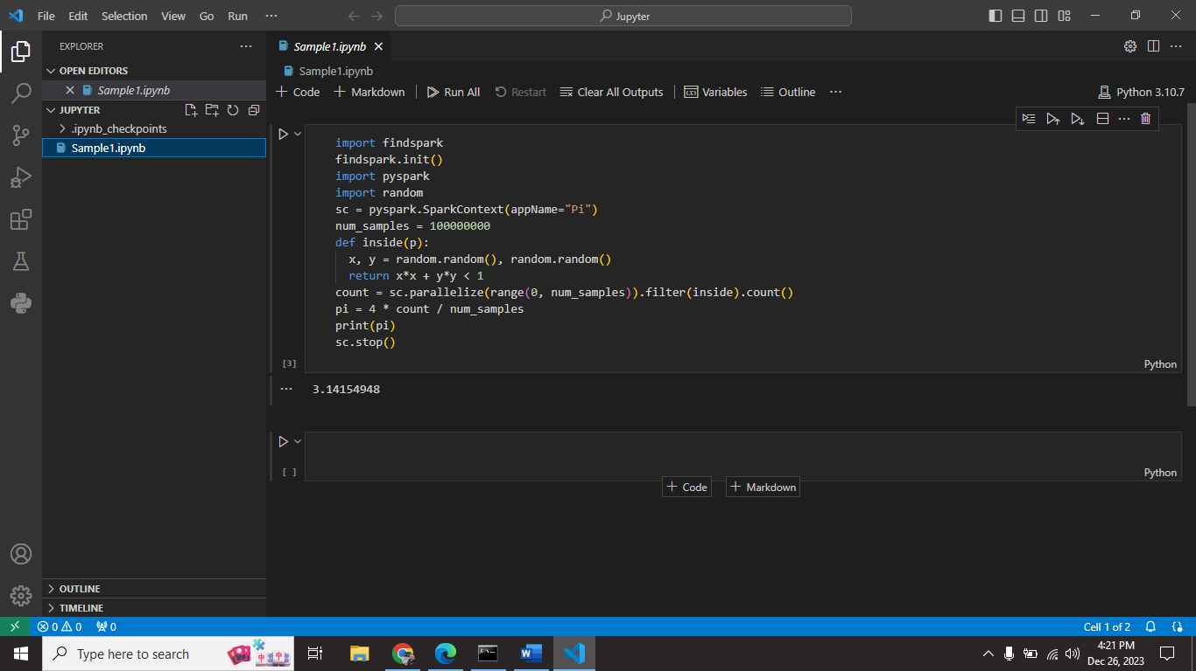

I successfully run one basic code on VS Code.